Project Title
AI Symptom checker and Treatment Advisor

Team Name:
ALPHA SQUAD

Team Members:
- Sk.Naseema
- Sk.Ruqayya
- Sd.Meharunnissa
- Sk.Fauzia Tasneem
- Sk.Asha

Phase-1: Brainstorming & Ideation

Objective:

Problem Statement:
Millions of people struggle with accessing timely and reliable health assessments, often leading to misdiagnosis, delayed treatment, or unnecessary hospital visits. Existing symptom checkers lack personalization, real-time tracking, and integration with modern health tools, making them inefficient and generic.
Purpose:
The Symptom Checker and Advisor Prototype aims to provide fast, accurate, and AI-powered health assessments to help individuals make informed decisions about their well-being. By integrating machine learning, real-time tracking, wearable connectivity, and mental health analysis, this solution will:
#Assist users in identifying possible health conditions based on symptoms.
#Reduce unnecessary hospital visits by guiding users on when to seek medical attention.
#Support telemedicine and remote healthcare services, improving accessibility.
#Promote mental health awareness by analyzing stress, anxiety, and emotional well-being.
Impact:
* Improved Healthcare Accessibility
* Early Disease Detection & Prevention
* Reduced Hospital Overload
* Smart & Personalized Health insights
* Mental Health Awareness & support

Key Points:
- Problem Statement:
* Lack of Quick & Reliable Health Assessments
* Limited Access to Healthcare in Remote Areas
* Overcrowded Hospitals & Unnecessary Doctor Visits
* Poor Tracking of Symptoms Over Time
* Ignoring Mental Health Symptoms

- Proposed Solution:
The Symptom Checker and Advisor is an AI-powered digital health assistant that helps users analyze their symptoms, track their health, and receive personalized medical guidance in real time. It aims to bridge the gap between self-diagnosis and professional healthcare, reducing unnecessary hospital visits while improving early disease detection.

How It Works:
Users input symptoms via text, voice, or images.
AI analyzes symptoms using medical databases and machine learning.
Personalized health advice is provided, including possible conditions
Tracks symptoms over time to detect patterns and alert users if conditions worse.
Integrates with wearables for real-time health data (heart rate, oxygen levels, etc.

Key Benefits:
Fast, AI-driven health assessments anytime, anywhere.
Reduces unnecessary hospital visits, easing healthcare burden.
Enhances accessibility with multilingual and voice support.
Supports mental health awareness, offering early intervention.

- Target Users:
This AI-powered Symptom Checker and Advisor will benefit a wide range of users by providing quick, reliable, and accessible health insights.
General Public:
* Individuals seeking quick symptom analysis without immediate doctor visits.
* People in remote or rural areas with limited access to healthcare facilities.
* Elderly individuals who need frequent health monitoring.
* Busy professionals looking for convenient, AI-driven health guidance

- Expected Outcome:
Improved Healthcare Accessibility
Early Disease Detection & Prevention
Reduced Hospital Overload & Efficient Healthcare Management
Smart & Personalized Health Insights
Mental Health Awareness & Support

Phase-2: Requirement Analysis

Objective:
Functions: User Management & Authentication
Symptom Analysis & AI-Powered Diagnosis
Real-Time Symptom Tracking & Monitoring
Wearable Device & Smart Health Integration
Technical: Frontend, backend, database and storage, AI & NLP, Security &
Compliance, Third-Party Integrations

Key Points:
- Technical Requirements: Frontend, backend, database and storage, AI & NLP,
Security & Compliance, Third-Party Integrations
- Functional Requirements: User Management & Access, Symptom Checker & AI Diagnosis
Real-Time Health Tracking & Alerts, Mental Health
Assessment & Support.
- Constraints & Challenges: Accuracy & Reliability of AI Diagnosis, Data Privacy etc..

Phase-3: Project Design

Objective:
ARCHITECTURE:
User Interface (UI)
(Web, Mobile App)
||
API Gateway
(REST/GraphQL APIs)
||
Backend & AI Processing
Symptom Analysis Engine (AI/ML)
NLP for Voice & Text Processing
Image Processing (OpenCV, AI)
||

Database | Third-Party | Security Layer
(PostgreSQL, | Integration | (OAuth 2.0,
MongoDB) | (google Fit, | HIPAA, GDPR)
| Telemedicine) |

USER FLOW:

User Starts → Login/Register → Enter Symptoms → AI Analysis → Possible Conditions & Risk Level
|
v
Recommendations (Self-care, Doctor Visit)
|
v
Wearable Data Integration (Optional)
|
v
Emergency Alerts (If Critical)
|
v
Telemedicine Consultation (Optional)
|
v
Health Report & Data Storage
|
v
END

Key Points:
- System Architecture Diagram:

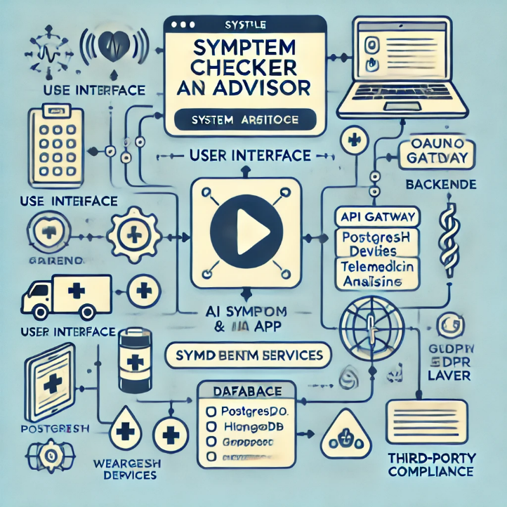
- User Flow: How a User Interacts with the System
- Login/Register or use Guest Mode.
- Enter symptoms via text, voice, or image.
- AI analyzes symptoms and predicts possible conditions.
- User receives recommendations (self-care, doctor visit, emergency alert).
- Track symptoms and get real-time alerts for worsening conditions.
- Consult a doctor via chat or video if needed.
- Get emergency support (nearby hospitals & urgent care suggestions).
- Mental health check-in (optional support for stress & anxiety).
- Secure storage of health records with privacy control.

- UI/UX Considerations:
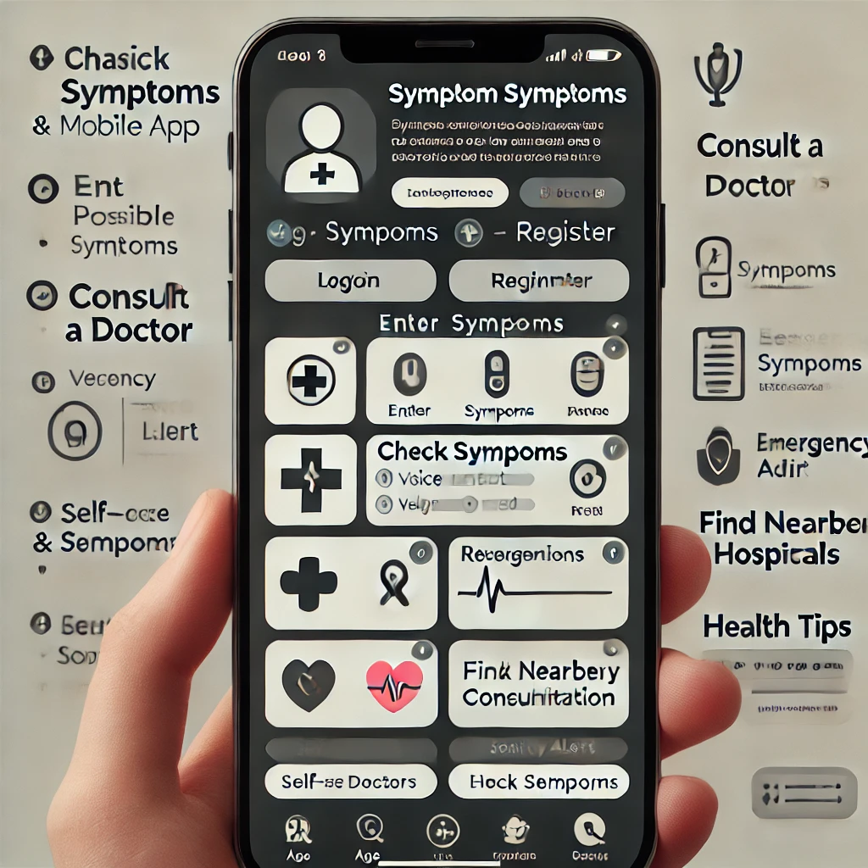

Phase-4: Project Planning (Agile Methodologies)

Objective:
  - Break down the tasks using Agile methodologies.

Key Points:
- Sprint Planning:
Work Assigned to
Pre-requisite Sk.Fauzia Tasneem, Sk. Asha
Build the solution Sk. Ruqayya, Sd. Meharunnissa
Submit the solution Sk. Naseema, Sk. Ruqayya, Sd.Mehar

- Timeline & Milestones:
* Hours 1-4: Plan the project, set up tools, and prepare the development environment.
* Hours 5-8: Build the basic user interface and backend for data handling.
* Hours 9-12: Train the AI model for symptom analysis and connect it to the system.
* Hours 13-16: Add extra features like doctor consultations and hospital search.
* Hours 17-20: Test everything to fix errors and improve performance.
* Hours 21-24: Deploy the project online and monitor for any final improvements.

Phase-5: Project Development

Objective:
- Frontend: Build a user-friendly interface using React.js (Web) or React Native (Mobile)
- Backend: Develop APIs with Node.js/Express.js for handling user requests
- AI Model: Train and integrate a symptom prediction system using Python & Machine Learning.
- Database: Securely store user and health data using MongoDB/PostgreSQL
- Integrations: Add telemedicine (chat/video calls), Google Maps for hospitals, and wearable device sync.
- Testing & Deployment: Perform unit, integration, and security tests before deploying to cloud platforms (AWS, Firebase, etc.)..

Key Points:
- Technology Stack Used:
** Frontend: React.js (for web) or React Native (for mobile) to create the user interface.
** Backend: Node.js with Express.js to handle user requests and connect to the database.
** AI & Machine Learning: Python with TensorFlow or Py Torch to analyze symptoms and predict possible conditions.
** Database: MongoDB (NoSQL) or PostgreSQL (SQL) to store user data securely.
**APIs & Integrations: Twilio for doctor consultations (chat/video), Google Maps for finding hospitals, and Apple Health/Google Fit for wearable data.
** Security: JWT & OAuth for user authentication and encryption to protect health data.
** Deployment: AWS, Firebase, or Digital Ocean for hosting and running the app smoothly.
- Development Process:

1️.Planning & Setup – Define requirements, choose technology, and set up the project.
2️. Frontend Development – Build user-friendly screens for symptom input, results, and doctor consultation.
3️.Backend Development – Create APIs to handle user data, symptom analysis, and authentication.
4️.AI Model Development – Train an AI to analyze symptoms and predict possible conditions.
5️.Database Integration – Store user profiles, medical history, and reports securely.
6️.Feature Enhancements – Add doctor consultations (chat/video) and hospital search.
7️.Testing & Debugging – Check for errors, improve performance, and secure user data.
8️.Deployment & Monitoring – Launch the system on cloud platforms (AWS/Firebase) and track performance.

- Challenges & Fixes:
# Symptom Analysis Accuracy – Improved AI with better datasets and expert feedback.
# Data Security & Privacy – Used encryption and ensured compliance with health regulations.
#Real-Time Doctor Consultations – Optimized video calls using better servers and APIs.
#User Experience Issues – Refined UI based on user feedback for smoother navigation.
#System Performance & Scalability – Optimized database queries and used cloud hosting for faster response times.

Phase-6: Functional & Performance Testing

Objective:
  - Ensure the project works as expected.

Key Points:
- Test Cases Executed: (List the scenarios tested)
- Bug Fixes & Improvements: (Mention fixes made)
- Final Validation: (Does the project meet the initial requirements?)
- Deployment (if applicable): (Hosting details or final demo link)

Final Submission
- Project Report Based on the templates
- Demo Video (3-5 Minutes)
- GitHub/Code Repository Link
- Presentation

